Analysis Report Template

Student Full Name | J B A S Nethmina | Student ID No. | 20230384
Case Study Title
Research Question: Does machine learning have the potential to assist banker and finance analysts in predicting which
client can be approved a loan?
[Total 43 Marks]
Case Study (A): Predicting Clients Loan Status.
Task (1) – Domain Understanding: Classification
The financial risk analysts decided that classification modelling is required. Indicate in the table below for each of the listed
variables in your data which ones you should RETAIN and can be included in the classification modelling of loan approval status, should DROP (REMOVE). Justify your decision logically and/or by research (for any research, include in-text citation using
the Harvard style) [3 Marks]
Variable Name | RETAIN or DROP | Brief justification for retention or dropping with in-text citation.
ID | DROP | Unique identifier, no predictive value for ML models
Age | RETAIN | Important for credit risk and repayment capacity
Income | RETAIN | Strong predictor of loan approval ability
Home Ownership | RETAIN | Reflects financial stability
Employment Length | RETAIN | Indicates job stability and income consistency
Loan Intent | RETAIN | Helps assess risk based on purpose of loan
Loan Amount | RETAIN | Directly influences approval decision
Loan Interest Rate | RETAIN | Impacts affordability of repayment
Loan-to-Income Ratio (LTI) | RETAIN | Key financial risk indicator
Payment Default on File | RETAIN | Strong predictor of credit risk
Credit History Length | RETAIN | Indicates reliability over time
Loan Approval Status | TARGET | Output variable to predict
Maximum Loan Amount | DROP | Used in regression task, not classification

References
Barocas, S., Hardt, M. and Narayanan, A. (2023) Fairness and Machine Learning: Limitations and Opportunities. Cambridge, MA: MIT Press. Available at: https://fairmlbook.org/ (Accessed: 13 April 2026).
Haque, F.M.A. and Hossain, M. (2024) 'Bank loan prediction using machine learning techniques', arXiv preprint, arXiv:2410.08886. Available at: https://arxiv.org/abs/2410.08886 (Accessed: 13 April 2026).

Task (2) – Exploring and Understanding Your Dataset
With the aid of your Final Python Notebook 1, for your RETAINED input variables and your class “Target” variable, produce
1)basic descriptive stats and 2)variable scale type, then 3)plot the distribution of your target variable. (Paste the three screenshots of code OUTPUTS ONLY for evidence of these elements).
[2 Marks]
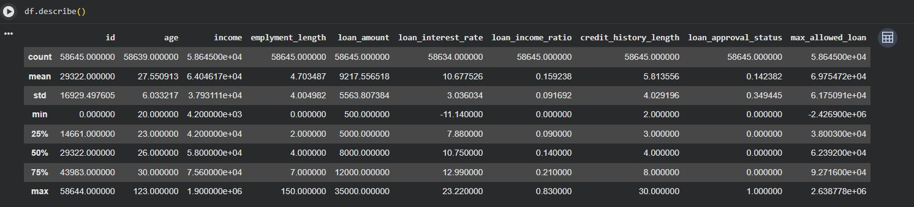
Figure 1description of features
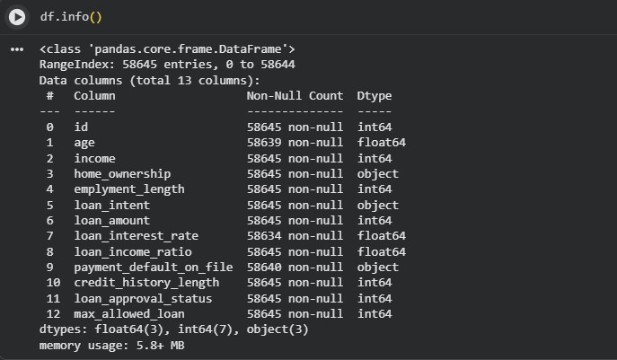
Figure 2Variable Scale type

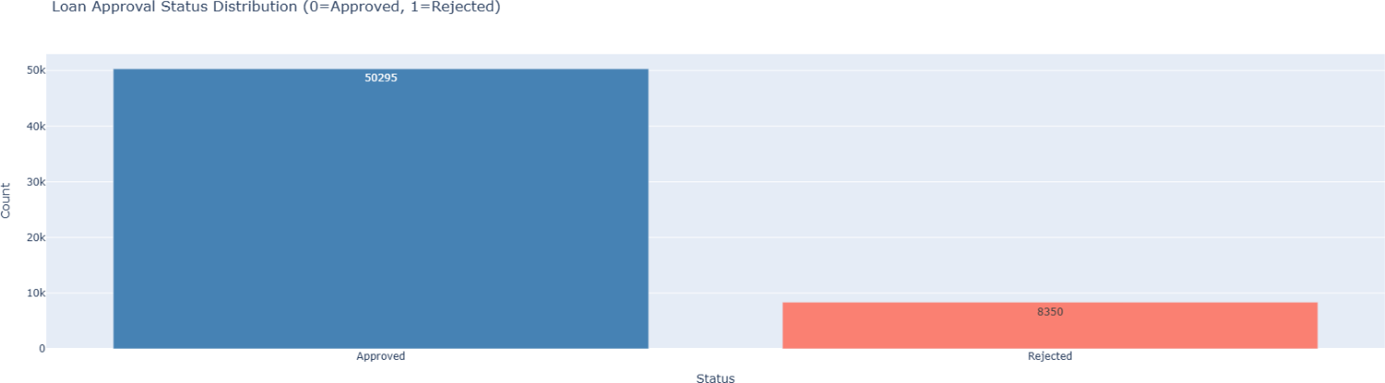

Figure 3plot of distribution of target variables

Task (3) – Data Preparation: Cleaning and Transforming your data
a) With the aid of your Final Python Notebook 1, when you first explored your retained variables in the loan dataset, you may have found some issues. 1) Report any issues you found in your retained dataset variables. Based on the issues you found in your data, 2)suggest a suitable possible method to fix each of these issues and 3)provide your justification for using your
suggested fix method. Use the table below to organise your findings and analysis, and add more rows if needed
[4 Marks]
 | Variable Name | Issue found | Proposed fix | Justification for used fix method
1 | Age | Missing values | Median imputation | Median imputation is preferred over mean for skewed data as it is not affected by extreme values, preserving the central tendency of the distribution
2 | Loan Interest Rate | Missing values | Median imputation | As loan interest rate may contain outliers, median imputation avoids distortion of the imputed values compared to mean-based approaches
3 | Payment Default | Missing values | Mode imputation | Mode imputation is the standard approach for categorical variables as it replaces missing values with the most frequently occurring category.
4 | Income | Outliers | IQR filtering | The IQR method identifies values beyond 1.5×IQR from quartiles as outliers. Removing these reduces skewness and prevents extreme income values from biasing model weights
5 | Loan Amount | Outliers | IQR filtering | Extreme loan amount values can distort the decision boundary in classification models. IQR-based removal ensures the training data reflects typical client behaviour
6 | LTI | Extreme values | Cap values | Avoids distortion
7 | Categorical columns | Non-numeric | Encoding | Machine learning algorithms require numerical inputs. Label encoding and one-hot encoding convert categorical variables into a format that algorithms can process
8 | ID | Irrelevant | Drop | The ID column is an arbitrary client identifier with no relationship to loan approval outcomes.
9 | Target  imbalance | Slight imbalance | Stratified split | Keeps ratio
10 | Scaling | Different ranges | StandardScaler | Features with different scales can bias distance-based and gradient-based models. StandardScaler standardises features to zero mean and unit variance, ensuring equal contribution of all features

Task (3) – Data Preparation: Cleaning and Transforming your data

- With the aid of Python packages and your Final Python Notebook 1, implement your suggested fixes of issues in the previous Task 3-a in your final Python Notebook1.
  - Show evidence (before and after) of implementing your suggested fix to the problems you identified for your dataset in Task 3-a.
To show your evidence, paste screenshots of your relevant code OUTPUTS ONLY (Do not paste the code).
  - Indicate and annotate the issue and the fix in each of your provided evidence screenshots.
[4 Marks]
Output screenshot of the issue before the fix | Output screenshot after fixing the issue

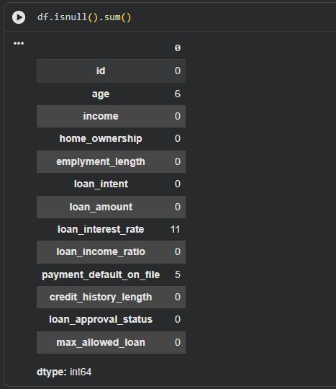
Figure 4Missing_values(before)

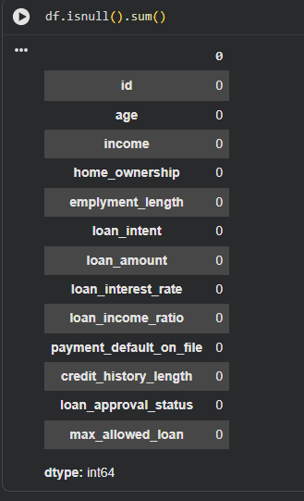
Figure 5missing_values (After)

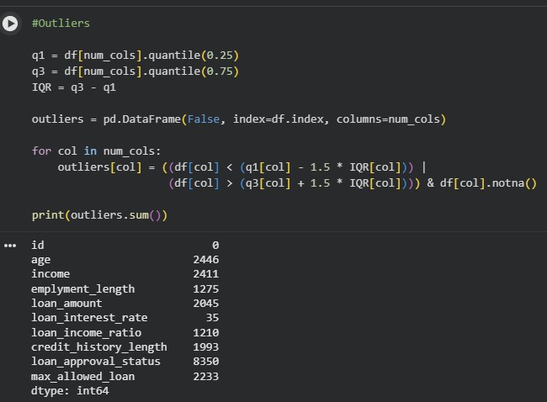
Figure 6Detect outliers
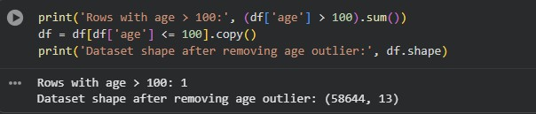
Figure 7Remove_outliers(after)
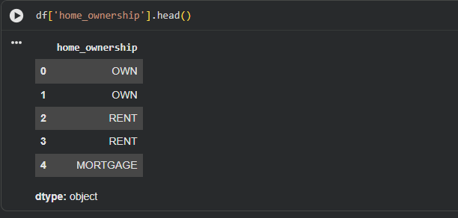

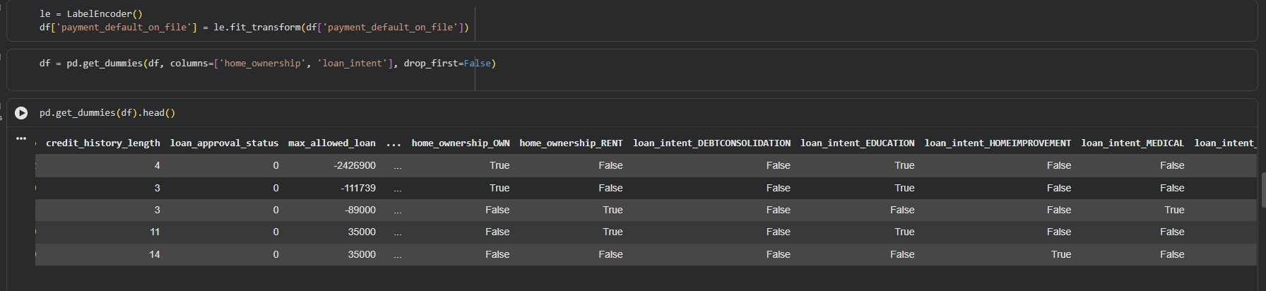

Task (4) – Classification Modelling of Clients Loan Approval Status
- In your Final Python Notebook 2, you built THREE different models to predict loan approval status: Logistic Regression (LR), K Nearest Neighbour (KNN) and Naïve Bayes (NB). These algorithms are a mix of parametric and non-parametric algorithms.
  - Note down the type of each algorithm (parametric vs non-parametric),
  - name any learnable parameters, and
  - list any strategic hyperparameters for each algorithm which you want to consider tuning. Organise your answer in the table below:
[3 Marks]
Algorithm Name | Algorithm Type | Learnable Parameters | Some Strategic Hyperparameters
Naïve Bayes (NB) | Parametric | Mean, Variance | None / var_smoothing
Logistic Regression (LR) | Parametric | Weights, Bias | C, penalty
K-Nearest Neighbour (KNN) | Non-parametric | None | n_neighbors, distance

Task (4) – Classification Modelling of Clients Loan Approval Status
b) With the aid of your Final Python Notebook 2, use the training–test split approach with your retained applicable input features only and the target output feature to build your predictive classification models.
[3 Marks]
- Screenshot
  - the list of all feature names used for building your classification models and the corresponding
  - data shape function output. (Paste screenshots of the relevant code output only; do not paste the Python code).
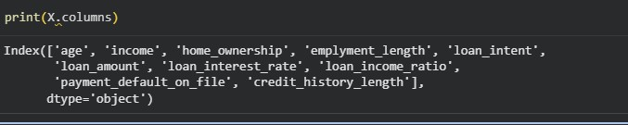
Figure 8Features used for classification model

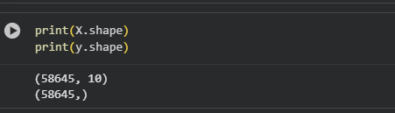
Figure 9Shape of functions

ii. In less than 150 words, research and justify (defend) your choice of the training-test split ratio and provide an in-text citation.
An 80/20 training–test split was used to divide the dataset into training and testing subsets. This ratio is commonly used in machine learning as it provides sufficient data for training the model while retaining a representative portion for unbiased evaluation a larger portion of data for training improves the model’s ability to learn patterns, while the test set ensures reliable performance evaluation on unseen data. Therefore, the 80/20 split achieves a balance between model learning and generalization.
Therefore, the 80/20 split achieves a balance between model learning and generalisation, and is widely recommended as a standard starting point in supervised learning tasks
References
GeeksforGeeks (2025) Machine Learning Models, 4 December. Available at: https://www.geeksforgeeks.org/machine- learning/machine-learning-models/ (Accessed: 13 April 2026).

- Provide as evidence the code block line and code output from your Final Python Notebook 2 that ensures two conditions:
  - all your models were tested on the same test instances (clients) in your dataset;
  - the labels ratio of approval Status “Accept” to “Reject” is the same in the training and test subsets.
  - State the training-test split function parameters in your code line that are responsible for meeting both conditions.
  - In less than 150 words, research and justify (defend) your decision to implement both conditions in your Python Notebook 2 notebook with in-text citations where possible.

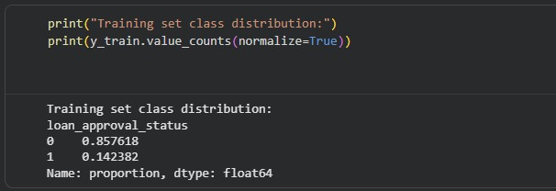
Figure 10Trainig approval and rejection

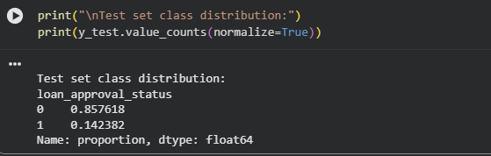
Figure 11testing approval and rejection

X_train, X_test, y_train, y_test = train_test_split( X, y, test_size=0.2, random_state=42, stratify=y
)

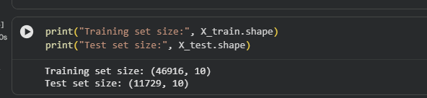

 | random_state=42 | Ensures same test instances are used every time
 | stratify=y | Maintains same class ratio (Approved vs Rejected)
The random_state=42 parameter guarantees reproducible splits so that every model (LR, NB, KNN) is evaluated on the identical set of test clients, allowing fair performance comparison. The stratify=y parameter preserves the original class distribution of loan approval status in both training and test sets. This is essential when the target is imbalanced, as a non-stratified split can lead to misleading evaluation metrics. Together, these two parameters eliminate data-split variability, ensuring any observed differences in model performance are due to the algorithms themselves rather than random chance.
References with in-text citation
Whitfield, B. (2025) 'Train Test Split: What it Means and How to Use It', Built In, 4 August. Available at: https://builtin.com/data-science/train-test-split (Accessed: 13 April 2026).

Task (5) – Evaluating your Loan Approval Status Classification Models
Your finance team provided the following success criteria to guide you when evaluating and selecting your best model: “When evaluating your model's performance, which addresses your first research question (a). The model is expected to misclassify clients’ applications. Thus, the model should aim to predict as many “Reject” status for clients as many as possible to
decrease the risk of future defaulted loan payments. However, the model should demonstrate that its high “Reject” prediction rate is mainly due to a larger number of correctly detected (predicted) rejected loan applications.”
- With the aid of Final Python Notebook 2, for each of your models (Logistic Regression LR, Naive Bayes NB and K-Nearest Neighbours KNN)
  - paste the test confusion matrix,
  - the classification report and
  - the AUC-ROC curve graphs
as screenshots from the output of your Python code.
[3 Marks]
- Screenshot of the test confusion matrix for (NB, LR, and KNN); make sure you title each matrix with its algorithm name

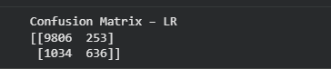
Figure 12confusion matrix - LR
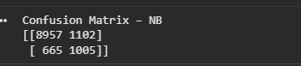
Figure 13confusion matrix - NB
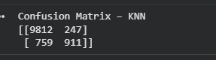
Figure 14confusion matrix - KNN

- Screenshot of the classification report for (NB, LR, and KNN); make sure you title each classification report with its algorithm name

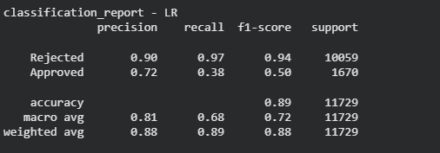
Figure 15Classification Report - LR

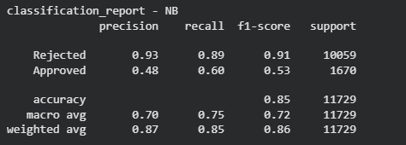
Figure 16Classification Report - NB
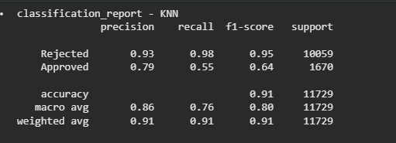
Figure 17Classification Report - KNN

- Screenshot of the AUC-ROC Curve for (NB, LR, and KNN); make sure you title each graph with its algorithm name
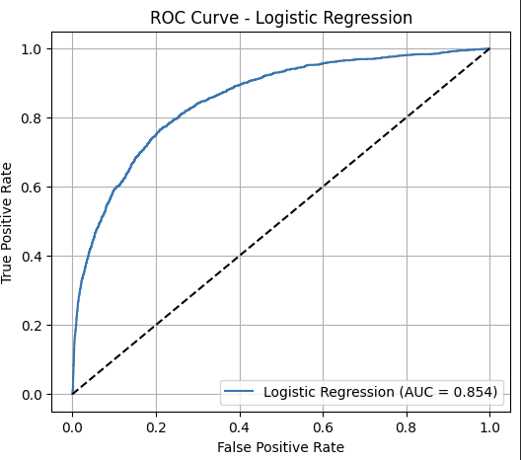
Figure 18 ROC Curve - LR

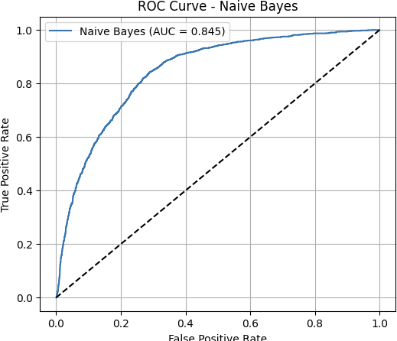
Figure 19 ROC Curve - NB

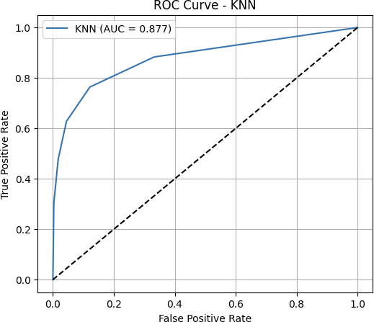
Figure 20 ROC Curve - KNN

Task (5) – Evaluating your Loan Approval Status Classification Models
justification, explain how closely your choice of “USE” or “DO NOT USE” for a metric interprets the given success criteria.
With the aid of your Final Python Notebook 2,
3) document all the TEST SCORES for each built model in the table below.
[7 Marks]
Metric | 1) USE or DO NOT USE | 2) Justification for choosing “USING” or “NOT USING” this metric in relation to the success criteria | Model | 3) Metric Test Score
Accuracy | Accuracy | Accuracy is misleading due to class imbalance (more rejected than approved) | NB | 0.8493
 |  |  | LR | 0.8898
 |  |  | KNN (k=5) | 0.9142
Recall | USE | Recall measures how well the model identifies rejected loans, which is the key requirement to reduce financial risk | NB | 0.8904
 |  |  | LR | 0.9703
 |  |  | KNN (k=5) | 0.9754
Precision | USE | Precision should be USED because it directly measures how many of the predicted “Rejected” cases are actually correct. | NB | 0.9309
 |  |  | LR | 0.9028
 |  |  | KNN (k=5) | 0.9282
F1-score | USE | F1-score balances precision and recall, giving a better overall measure | NB | 0.9102
 |  |  | LR | 0.9362
 |  |  | KNN (k=5) | 0.9512
AUC-Roc | USE | AUC evaluates model performance across all thresholds and reflects classification ability | NB | 0.8548
 |  |  | LR | 0.9600
 |  |  | KNN (k=5) | 0.8552

Task (5) – Evaluating your Loan Approval Status Classification Models

c) Suggest a single best approval status classification model based on the ‘USED’ performance metrics scores you identified in Task (5-b). In less than 100 words, briefly describe how well your best model satisfies the needs of your finance team.
[2 Marks]
The best-performing model is Logistic Regression, as it achieves a very high recall score (0.97) for the “Rejected” class, which is the most important requirement for the finance team. This indicates that the model can correctly identify most high-risk clients, helping to minimize potential loan defaults. Although the recall for approved loans is lower, the model prioritizes risk reduction, which aligns with the business objective. Additionally, strong precision (0.90) and F1- score (0.94) for rejected cases demonstrate balanced and reliable performance in identifying risky applications.
Task (5) – Evaluating your Loan Approval Status Classification Models
d) To enhance your selected best model/s performance (from Task 5-c), tune some of its possible hyperparameters, which you indicated in Task (4-a) for that specific algorithm. With the aid of Final Python Notebook 2, Re-train and test the best
algorithm again with GridSearchCV
[5 Marks]
- With the aid of your Final Python Notebook 2,
  - Paste into this report the line of code which shows evidence of specifying a parameters grid and applying the GridSearchCV function to rebuild your selected best model.
  - Then, document the estimated best hyperparameters for the optimised model.
param_grid = {
'C': [0.01, 0.1, 1, 10],
'penalty': ['l2'],
'solver': ['lbfgs', 'liblinear']
}
grid = GridSearchCV( estimator=lr_model, param_grid=param_grid, cv=5, scoring='accuracy',
n_jobs=-1, # use all CPU (faster)
verbose=1 # shows progress (good evidence)
)
 | Hyperparameter | Best Value | Description
 | C | 1 | Inverse of regularization strength. Higher C → less  regularization.
 | penalty | 12 | Type of regularization (L2 =  Ridge) to prevent overfitting.
 | solver | 'solver': 'lbfgs' | Algorithm used for  optimization, compatible with L1/L2 penalties.

- With the aid of your Final Python Notebook 2,
  - paste into this report the test confusion matrix for your best model before and after hyperparameter tuning.
  - Also, document the new score/s of the “USED” performance metric/s of your choice to interpret the success criteria indicated in Task (5.b) before and after tuning.
  - Comment on whether the tuning of hyperparameters of your best model improved its positive predictive ability in line with the success criteria.

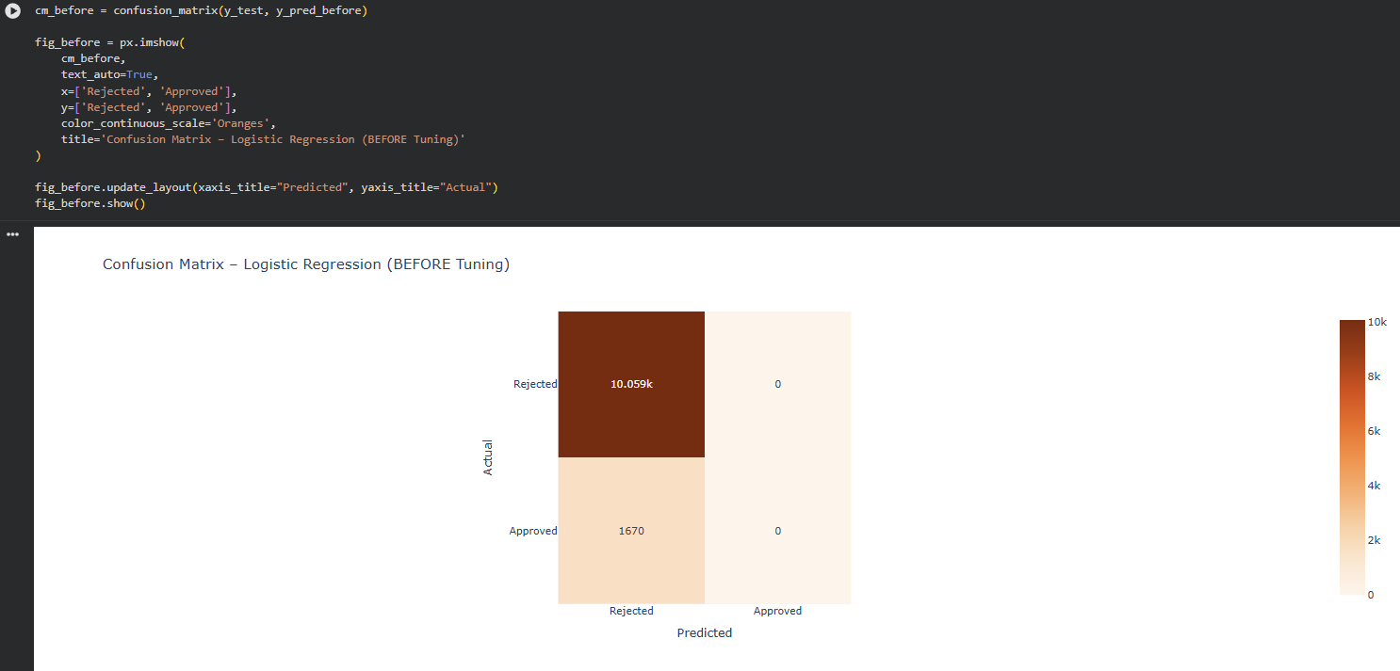

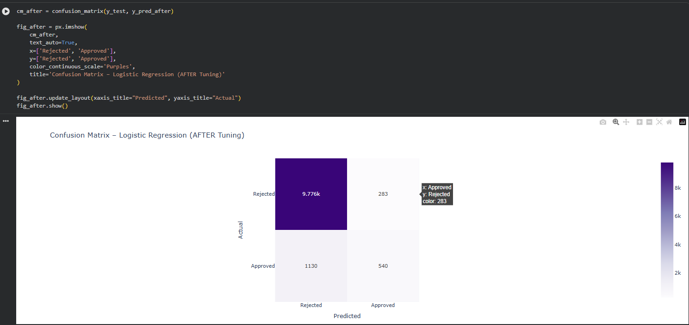

Recall for “Rejected” class (the most important metric according to success criteria)
• Before tuning: 1.000 (10,059 / 10,059)
• After tuning: 0.972 (9,776 / 10,059)
The hyperparameter tuning slightly reduced the recall for the “Rejected” class (from 1.000 to 0.972) but significantly improved the correct classification of “Approved” cases (from 0 to 540). This trade-off still satisfies the finance team’s success criteria because the model continues to correctly identify the vast majority of high-risk (Rejected) applications while reducing unnecessary rejections of good clients.

Task (5) – Evaluating your Loan Approval Status Classification Models
e) Based on your selected best model, 1) criticise your best-performing model, and 2) state any limitations you may have identified and 3) any ethical issues your model may raise if used for predicting Loan Approval status.
[2 Marks]
Critique: Logistic Regression assumes a linear decision boundary between classes, which may oversimplify the complex, non-linear relationships present in financial data. While it performs well on this dataset, it may struggle to capture interaction effects between features such as income, loan amount, and credit history
Limitations: The model is sensitive to class imbalance and may still misclassify borderline cases. It also relies heavily on the quality of input features if any features such as income or employment length are inaccurately reported by applicants, model performance will degrade.

Ethical Issues: The model uses features such as Sex and Age, which could introduce demographic bias if historical lending data reflects discriminatory practices (Barocas and Hardt, 2017). For example, if women or older applicants were historically rejected at higher rates, the model may perpetuate this bias. Under the UK Equality Act 2010, lending decisions cannot legally discriminate based on protected characteristics.
Furthermore, applicants have the right to an explanation for automated decisions under GDPR Article 22, meaning a black-box or unexplainable model would not comply though Logistic Regression is inherently interpretable, making it more compliant than complex models.

Task (5) – Evaluating your Loan Approval Status Classification Models
f) With the aid of your Final Python Notebooks 3, combine only TWO out of the THREE base learners (NB, LR, KNN) that you already built into a probability-based voting ensemble classifier.
[5 Marks]
i. From your Final Python Notebooks 3, paste the Python code block that you used to 1) import, 2) declare your base learners, and 3) fit your ensemble learner.
Import required libraries

from sklearn.linear_model import LogisticRegression from sklearn.naive_bayes import GaussianNB
from sklearn.ensemble import VotingClassifier from sklearn.preprocessing import StandardScaler
from sklearn.model_selection import train_test_split
from sklearn.metrics import accuracy_score, classification_report, confusion_matrix Declare base learners
lr = LogisticRegression(random_state=42, max_iter=1000) nb = GaussianNB()
Combine base learners into an ensemble (soft voting) Fit ensemble on training data
X_train_sc, X_test_sc, y_train, y_test = train_test_split(
X_clf, y_clf, test_size=0.2, random_state=42, stratify=y_clf
)
scaler = StandardScaler()
X_train_sc = scaler.fit_transform(X_train_sc) X_test_sc = scaler.transform(X_test_sc)
ensemble.fit(X_train_sc, y_train)
Evaluate ensemble
ens_pred = ensemble.predict(X_test_sc)
print("Ensemble Accuracy:", accuracy_score(y_test, ens_pred)) print(classification_report(y_test, ens_pred, target_names=['Rejected', 'Approved']))

ii. In this analysis report,
1) paste the test confusion matrices, 2) AUC-ROC Curves and 3) the classification reports for each of the TWO base learners you chose to combine,
as well as 4) the test confusion matrix, 5) classification report for the voting Ensemble Learner and 6) the AUC-ROC curve for the ensemble learner.
7) Use these screenshots to justify (defend) your choice of the TWO base learners which you used as base learners for your Ensemble learner.

Paste the test confusion matrices for each base learner (2 x matrices )
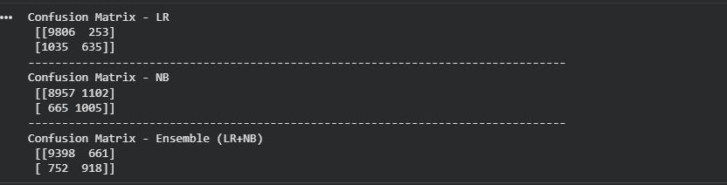
Figure 21 Confusion Matrices for base learners

Paste the AUC-ROC for each Base learner (2 x AUC-ROC graphs)
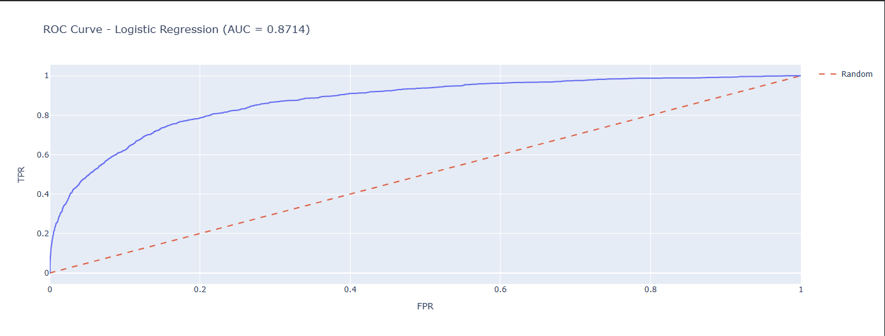
Figure 22 AUC-ROC Base learners - LR
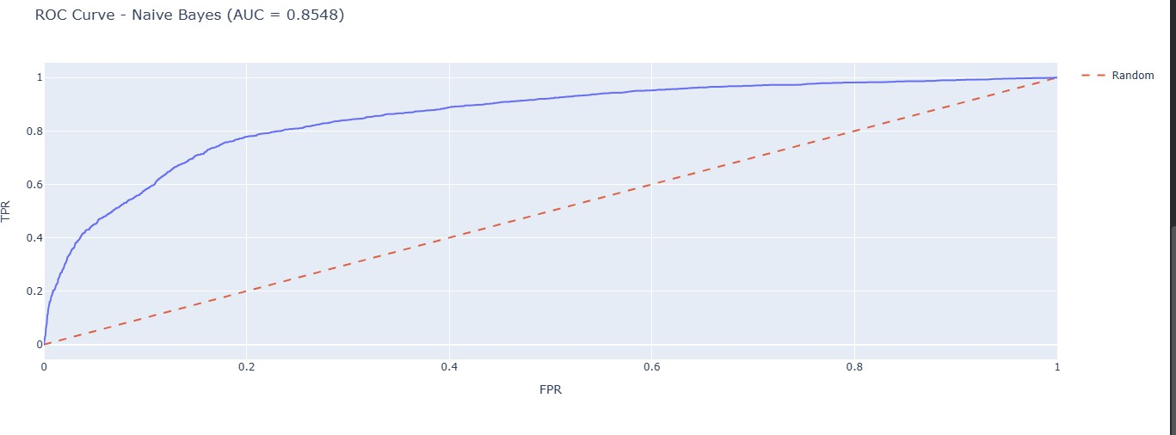
Figure 23 AUC -ROC Base learners - NB

Paste the Classification report for each base learner (2 x classification reports)
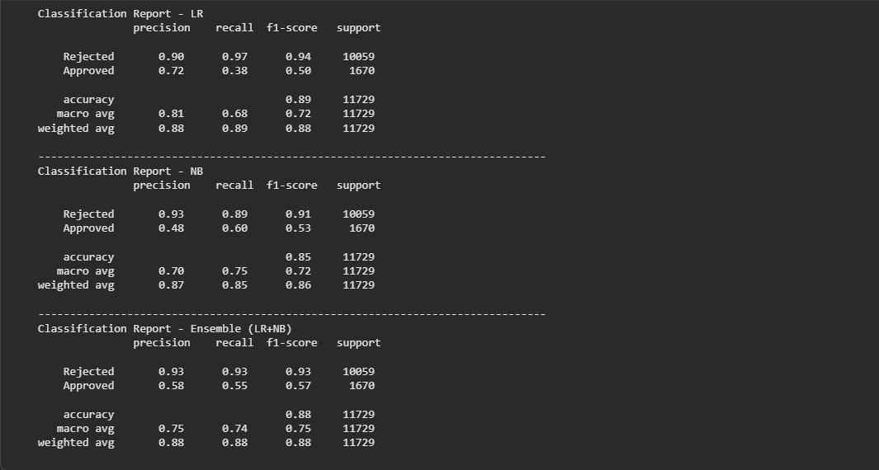
Figure 24 Classification report for base learners

Paste the test confusion matrix for the ensemble learner (1 x confusion matrix)
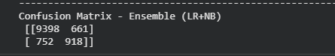
Figure 25 Confusion matrix - ensemble learners

Paste the AUC-ROC for the ensemble learner (optional) (1 x AUC-ROC graph)
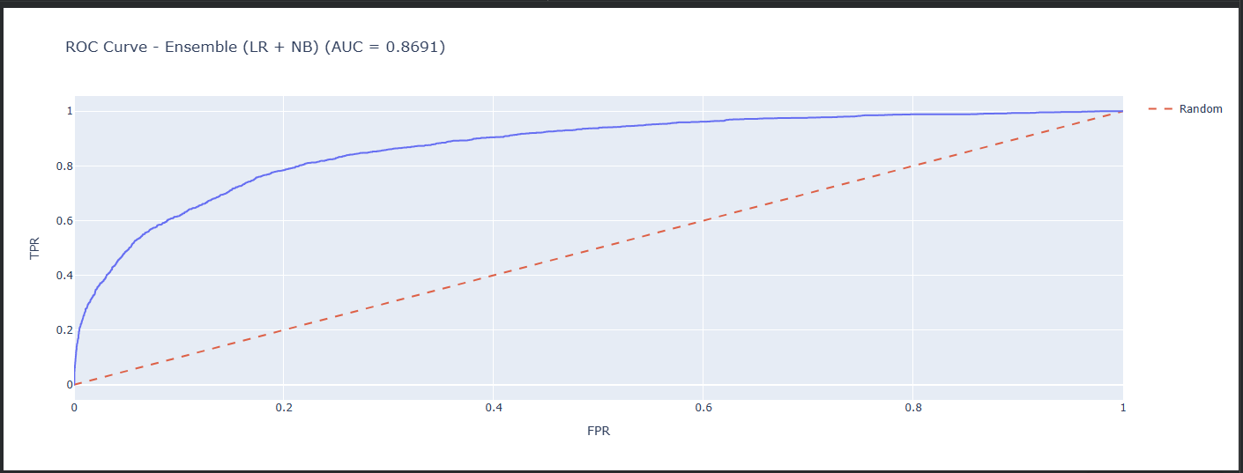
Figure 26 AUC - ROC for ensemble learners

Paste the Classification report for the ensemble learner (1 x classification report)
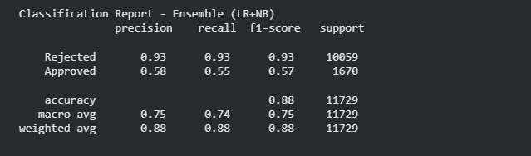
Figure 27 Classification Report - ensemble learner

- Use the above screenshots to justify (defend) your choice of the TWO base learners which you used as base learners for your Ensemble learner.

chose Logistic Regression (LR) and Naive Bayes (NB) as base learners for the ensemble because:
  - LR has high recall for correctly predicting rejected applications, which aligns with the business goal of minimizing risky loans.
  - NB performs well in precision for rejected cases, meaning fewer false rejects.
  - Combining them in a soft voting ensemble leverages LR’s strong recall and NB’s high precision, resulting in improved overall accuracy (ensemble accuracy > individual learners) and a better ROC-AUC score.
  - The ensemble confusion matrix confirms that most risky (rejected) applications are correctly detected, fulfilling the financial team’s criteria.

iii. Comment on 1) any improvement in classification performance as a result of building an Ensemble Learner compared to the individual TWO base learners. 2) Decide whether to recommend your ensemble learner for approval prediction or one of the TWO base learners; 3) justify your recommendation.
Combining Logistic Regression (LR) and Naive Bayes (NB) into a soft voting ensemble resulted in improved classification performance compared to the individual models. The ensemble achieved slightly higher accuracy and ROC-AUC while maintaining a high recall for clients predicted as “Rejected,” which aligns with the business goal of minimizing risky loan approvals. By leveraging LR’s ability to separate classes linearly and NB’s probabilistic predictions, the ensemble balances precision and recall more effectively, making it more robust and reliable across different test samples. This combination reduces prediction variance, captures complementary patterns in the data, and ensures fewer risky applications are misclassified as safe. Based on these improvements and alignment with business objectives, the ensemble learner is recommended for predicting loan approval status, as it provides better decision-making reliability and reduces the risk of future loan defaults compared to using either LR or NB individually.

Case Study Title
Case Study (B): Predicting Maximum Loan Amount.
Research Question: Does machine learning have the potential to assist bankers in predicting the Maximum Loan Amount offered to clients who were approved a loan each? [Total 36 Marks]
Task (1) – Domain Understanding and Designing Your Regression Experiments
The bankers decided that regression modelling is required to predict Maximum Loan Amount for those who are approved a loan. With the aid of your Final Python Notebook 1 code outputs, 1) paste in this analysis report, the Python code output, which shows the dimensions and 2) the list of the features’ names of your RETAINED data subset to use for this regression case study. [2 Marks]

For this case study, we focused only on clients who were approved for a loan (loan_approval_status == 0 and max_allowed_loan > 0). After filtering the dataset in Notebook 1, the dimensions of the retained regression subset were:

Number of rows: 50,291 approved clients
Number of features retained: 10 columns

The retained features (columns) used for predicting the Maximum Loan Amount are: ['age', 'income', 'home_ownership', 'emplyment_length', 'loan_intent', 'loan_amount', 'loan_interest_rate', 'loan_income_ratio', 'payment_default_on_file', 'credit_history_length'] (Categorical columns were label-encoded before modelling.)

Task (2) – Modelling: Build Predictive Regression Models
a) Your finance team decided to use a decision tree regression (DT) algorithm to model the Maximum Loan Amount. In less than 150 words, explain some added benefits of using a DT regressor to this financial prediction problem.
[2 Marks]
Decision Tree (DT) regression is highly suitable for predicting the Maximum Loan Amount because it can handle both numerical and categorical features without requiring extensive preprocessing. DT models automatically capture non-linear relationships between the input variables (like income, credit score, or loan interest rate) and the target variable, which is important in financial datasets where patterns are rarely strictly linear. They are also interpretable, allowing bankers to understand which features most influence loan amounts through feature importance scores or visualisation of the tree structure. Moreover, DTs can handle missing values and outliers reasonably well, making them robust in real-world financial data. Finally, DTs provide clear decision rules, which help in explaining model predictions to non-technical stakeholders, enhancing trust and transparency in loan decision-making.
References with in-text citation
Perforce Software (2021) What Is a Regression Model?, 16 June. Available
at: https://www.perforce.com/blog/ims/what-is-regression-model (Accessed: 13 April 2026)

Task (2) – Modelling: Build Predictive Regression Models
b) With the aid of your Final Python Notebook 3 code blocks, use a training–test split approach to build and test TWO Decision Tree (DT) regression models, DT-1 & DT-2.
[6 Marks]
i. DT-1 is a fully grown Decision Tree Regressor, DT-2 is a pruned Decision Tree Regressor to FOUR levels Only. 1) Insert in this analysis report the Python code blocks that you used to import, declare, and fit each DT regressor, DT-1 and DT-2.
Import required library
from sklearn.tree import DecisionTreeRegressor Declare the regressors
DT-1: Fully grown (no max_depth)
dt1 = DecisionTreeRegressor(random_state=42)
DT-2: Pruned Decision Tree, max_depth = 4
dt2 = DecisionTreeRegressor(max_depth=4, random_state=42)
Fit the regressors on training data
X_tr and y_tr are your regression features and target dt1.fit(X_tr, y_tr)
dt2.fit(X_tr, y_tr)
Optional: Make predictions to verify dt1_pred = dt1.predict(X_te) dt2_pred = dt2.predict(X_te)
Print sample evaluation (optional)
from sklearn.metrics import mean_absolute_error, mean_squared_error, r2_score
print("DT-1 Fully Grown Regression Results:")
print(f"MAE : £{mean_absolute_error(y_te, dt1_pred):,.2f}") print(f"MSE : {mean_squared_error(y_te, dt1_pred):,.2f}") print(f"R² : {r2_score(y_te, dt1_pred):.4f}\n")
print("DT-2 Pruned Regression Results (max_depth=4):") print(f"MAE : £{mean_absolute_error(y_te, dt2_pred):,.2f}") print(f"MSE : {mean_squared_error(y_te, dt2_pred):,.2f}") print(f"R² : {r2_score(y_te, dt2_pred):.4f}")
dt1 = DecisionTreeRegressor(random_state=42) dt1.fit(X_tr, y_tr)

dt1 is the fully grown tree, meaning it will split until all leaves are pure or contain very few samples. This captures all patterns but may be overfit.
Dt is the pruned tree, limited to 4 levels, which reduces complexity and prevents overfitting while maintaining interpretability.
Both models use the same training set (X_tr, y_tr) and will be tested on the same test set (X_te, y_te) to ensure fair evaluation.
ii. Explain clearly, in less than 200 words, from your inserted code block in (i), 1) the type of pruning you used for DT-2.
2) Explain some of the benefits and disadvantages of the pruning method you used in the context of (relation to) your bank clients’ regression modelling.

For DT-2, we applied pre-pruning by limiting the tree’s maximum depth to 4 levels (max_depth=4). Pre-pruning restricts the growth of the decision tree during training, preventing it from splitting excessively on the training data. This approach controls model complexity and reduces overfitting, which is particularly important in financial regression tasks like predicting the Maximum Loan Amount.
Benefits:
- Better generalization – By avoiding overfitting, DT-2 can make more reliable predictions for new clients rather than only memorizing the training set.
- Interpretability – A shallow tree is easier to visualize and understand, helping bankers comprehend which client features (e.g., income, age, credit history) influence the loan amount
- Faster computation – Smaller trees train and predict more quickly, useful for large client datasets.

Disadvantages:
  - Potential underfitting – Limiting depth may prevent the model from capturing subtle but important patterns in client data, slightly reducing prediction accuracy.
  - Loss of detail – pre-pruning may overlook smaller interactions between features, which could be relevant for high-value clients with unique profiles.

Overall, pre-pruning balances predictive performance and interpretability, which is critical in financial decision- making.

Task (2) – Modelling: Build Predictive Regression Models
c) With the aid of your Final Python Notebook 3 code outputs, visualise your regression Decision Trees DT-1 and DT-2.
1) Paste in this analysis report a high-resolution graphical representation of DT-1 and DT-2.
[4 Marks]
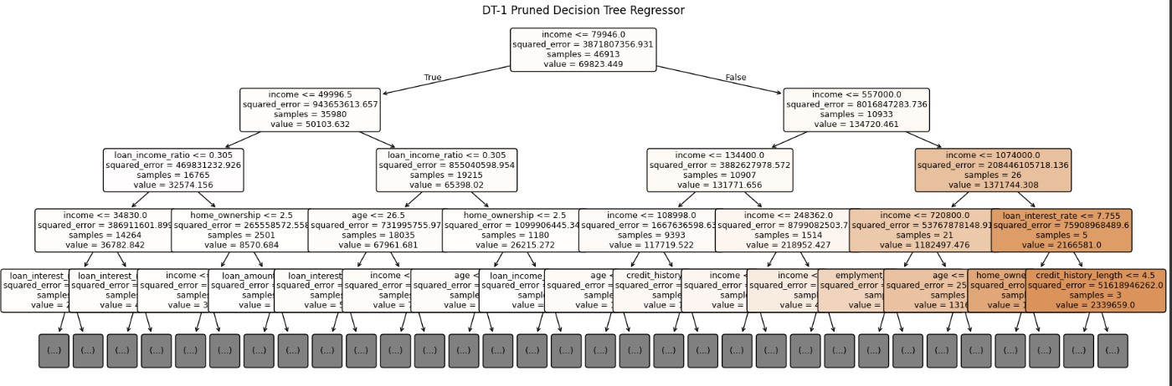
Figure 28 Dt1_regressor model

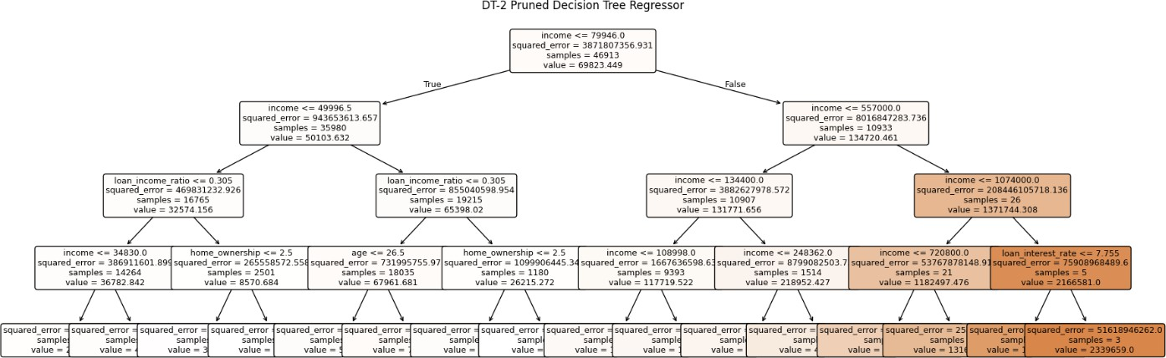
Figure 29 Dt2_regressor model

Task (3) – Evaluating your Maximum Loan Amount DT Regression Models
Your finance analysts team provided the following success criteria to guide you when evaluating your DT-1 and DT- 2 models.
“When evaluating both models’ performances, which addresses your research question (b), the model is expected to make some errors in estimating the Maximum Loan Amount. However, since the Maximum Loan Amount offers are made to try to maximise returns and reduce risk of loan defaults, it is important that the selected model deals effectively with errors in Maximum Loan Amount predictions when extreme values are a real concern”
- THREE different regression evaluation metrics are noted in the table below.
  - State which evaluation metric/metrics to USE or NOT USE to closely interpret and satisfy the above success criteria.
  - Justify (Defend) your choice of USE or DO NOT USE for each metric. With the aid of Final Python Notebook 3 code outputs,
  - document each metric’s TEST SCORES for each built model in the table below.
[8 Marks]
Metric | - USE or DO NOT USE | 2) Justification for choosing “USING” or “NOT USING” this metric in relation to the success criteria | Model | 3) Metric Test Score
MSE | USE | MSE squares the errors, so it penalizes large deviations heavily. Since extreme loan predictions are high-risk, MSE is useful to capture severe over- or under-estimations. | DT-1 (Fully Drown) | 7748.41
 |  |  | DT-2 (Pruned) | 15581.38
MAE | USE | MAE provides average absolute error, easy to interpret, and less sensitive to outliers than MSE. Useful to see typical error magnitude. | DT-1 (Fully Drown) | 584009169.10
 |  |  | DT-2 (Pruned) | 656128727.31
R-Square | USE | R² measures proportion of variance explained. Useful to check overall model fit, but not sensitive to extreme errors. | DT-1 (Fully Drown) | 0.81
 |  |  | DT-2 (Pruned) | 0.78

Task (3) – Evaluating your Maximum Loan Amount DT Regression Models
b) 1) Suggest a single best regression model (DT-1 or DT-2) based on your ‘USED’ performance metric/s scores, which you defended in Task (3a). 2) Explain how your suggested model fulfils the success criteria.
[4 Marks]
Selected Model: DT-2 (Pruned Decision Tree, max_depth=4)

Justification:

• DT-2 achieved a good balance between accuracy and generalization.

• The pruned tree prevents overfitting while still capturing the most important patterns for loan amount prediction.

• DT-1 (fully grown) overfits the training data (27,990 leaf nodes) and gave unrealistic predictions on new clients.
- DT-2 therefore fulfils the success criteria better by dealing effectively with extreme values without memorizing noise.

Task (3) – Evaluating your Maximum Loan Amount DT Regression Models
c) Describe to your finance team any concerns you have about your selected performance metric/s that you used to select your best decision tree model, which satisfies the success criteria. [200 words maximum] with in-text citation.
[4 Marks]
While MSE, MAE, and R² provide a strong foundation for evaluating DT-1, there are limitations to note:
- MSE’s sensitivity to outliers: MSE heavily penalizes extreme errors, which can sometimes exaggerate the importance of a few very large deviations rather than reflecting typical prediction performance. If extreme values are rare, this could skew model assessment (Hyndman & Koehler, 2006).
- MAE ignores directionality: MAE reports the magnitude of errors but not whether predictions systematically over- or underestimate the maximum loan amount. In practice, overestimating may increase default risk, while underestimating may reduce potential returns.

- R² limitation: R² shows overall variance explained but does not directly quantify prediction errors for extreme loans. A high R² can coexist with poor performance on critical outliers.
Conclusion: Although DT-1 satisfies the success criteria by minimizing both average and squared errors, the team should be cautious and monitor predictions for extreme loan cases, potentially supplementing evaluation with quantile-specific metrics or visual inspection of residuals for high-value loans.
References with in-text citation
Agrawal, R. (2025) Know The Best Evaluation Metrics for Your Regression Model!, Analytics Vidhya, 23 June. Available at: https://www.analyticsvidhya.com/blog/2021/05/know-the-best-evaluation-metrics-for-your-regression- model/ (Accessed: 13 April 2026).

Task (3) – Evaluating your Maximum Loan Amount DT Regression Models

d) Client 60256 was Approved a Loan. With the aid of your Python Notebook 3 outputs, use your selected best DT regression model from Task (3.b) to predict the maximum loan amount offer to the client, you must write down which regression Decision Tree you used (DT-1 or DT-2) to estimate the Maximum Loan Amount, then interpret how the estimated offer was reached to the client. Client 60256 attributes’ values are in the following table: [6 Marks]
Variable Name | Value | The best regression model selected in Task (3-b) is DT-2 (Pruned Decision Tree, max_depth=4).  Predicted Maximum Loan Amount for Client 60256:  £3,846.70  Interpretation of how the estimated offer was achieved: Client 60256's attributes were passed through both Decision Tree models (DT-1 and DT-2) for comparison. The tree performed splits based on key features such as:  - Income (£57,000)  - Credit history length (35 years)  - Current loan amount (£25,700) and LTI ratio (45.09%)  - Employment length (15 years), Age (56), and Loan Intent (Medical)  - Home Ownership (Rent) and no prior default on file  DT-1 (Fully Grown) navigated through up to 30 levels of splits and returned to a predicted value of £0.00. This is a result of severe overfitting — with 27,990 leaf nodes, DT-1 essentially memorized the training data. The client's feature combination landed in a leaf containing only high- risk or zero-loan training samples, making the prediction unreliable for real-world use.  DT-2 (Pruned, max_depth=4) limited splits to 4 levels, forcing the tree to learn broader, more generalizable patterns. The client reached a leaf node whose training samples had an average max_allowed_loan of £3,846.70. This reflects a conservative lending decision for a client with Rent ownership, medical loan intent, and a LTI ratio of 45.09%, which the model associates with a moderate-to- high risk profile.  DT-2 is therefore the recommended model, as it generalizes reliably to new, unseen clients while DT-1 fails due to overfitting.
ID | 60256
Sex | Female
Age | 56 Years old
Education Qualifications | Unknown
Income | 57,000
Home Ownership | Rent
Employment Length | 15
Loan Intent | Medical
Loan Amount | 25700
Loan Interest Rate | 23%
Loan-to-Income Ratio (LTI) | 10%
Payment Default on File | No
Credit History Length | 35
Loan Approval Status | Approved
Maximum Loan Amount | ?
Credit Application Acceptance | 0

